Customer Churn Analysis in the Telecommunications Industry

Name: Ngo Dieu Khanh Linh
Date: 9 June 2026

Table of contents

I. Introduction 2
a. Problem Statement 2
b. Research Question 2
c. Objectives 2
II. Methodology 2
III. Data Preprocessing 3
IV. EDA analysis 5
1. Overview Distribution 5
2. Single Factor Analysis 6
a. Customer Profile 6
b. Payment & Services 6
3. Relationship Analysis 9
a. Tenure Group x Charge Tier 9
b. Contract x Tenure Group 9
c. Internet Service x Tech Support 10
d. Internet Service x Charge Tier 10
e. Contract x Payment Method 11
f. Senior Citizen x Contract 11
4. Revenue Impact 12
a. Monthly Revenue Loss 12
b. Top 30 High-risk Customers by Risk Score 13
c. Annual Revenue Loss if Current Churn Rate Continues 13
V. Visualization 14
VI. Predictive analysis 15
a. Variables Conversion 15
b. Model Interpretation 17
c. Confusion Matrix 18
d. Top 30 High-risk Customer by Probability 20
e. Limitations 20
VII. Conclusion and Recommendations 21
VIII. References 22

Introduction

Problem Statement
The telecommunications industry is highly competitive, with providers under constant pressure to retain customers as acquisition costs significantly exceed retention costs. Customer churn poses a direct threat to revenue and profitability, yet identifying its drivers remains challenging, contract flexibility, service quality, pricing and add-on engagement interact in ways difficult to isolate without systematic analysis (Anisha et al. 2025). Without clear understanding, retention efforts remain reactive and ineffective. This report analyses customer churn behaviour for a telecommunications provider to identify the highest-risk segments, quantify the financial impact, and deliver evidence-based retention recommendations.

Research Question
"Which customer segments are most likely to churn, what is the financial impact, and what retention strategies can be recommended to reduce churn rate?"

Objectives
- Identify customer and service characteristics most strongly associated with churn
- Quantify the revenue impact of current and projected churn
- Statistically validate key churn drivers through predictive modelling
- Provide actionable recommendations grounded in analytical findings

Methodology
- Data Collection and Preparation
- Imported raw data into SQL Server as a staging table, preserving the original source for auditability
- Conducted data quality checks including duplicate detection, missing value identification and data type verification; cleaning and feature engineering transformations to produce a structured, analysis-ready table
- Exploratory Data Analysis
- Executed structured SQL queries to examine churn patterns across single and combined customer and service factors
- Identified key churn drivers through segment-level aggregations and multi-factor comparisons; quantified revenue impact and constructed a rule-based risk scoring model to identify highest-risk active customers
- Visualisation
- Built an interactive Power BI dashboard to present churn distributions, segment comparisons and revenue impact across two pages with dynamic slicers for business exploration
- Predictive Modelling
- Applied logistic regression in R to statistically validate significant churn predictors identified during EDA
- Evaluated model performance using a confusion matrix and generated individual churn probability scores for active customers

Data Preprocessing
The dataset comprises 7,043 customer records across 21 variables, covering customer demographics (gender, age, dependents, senior citizen, tenure), service subscriptions (internet, phone, streaming, security add-ons), contract and billing details (contract type, payment method, monthly and total charges), and a binary churn indicator representing whether the customer has left the service.
The raw dataset was imported into SQL Server as a staging table telecustomer using Import Flat File wizard, preserving all original values without modification. All 21 columns were verified against their expected data types, no data types issues were found in this dataset.

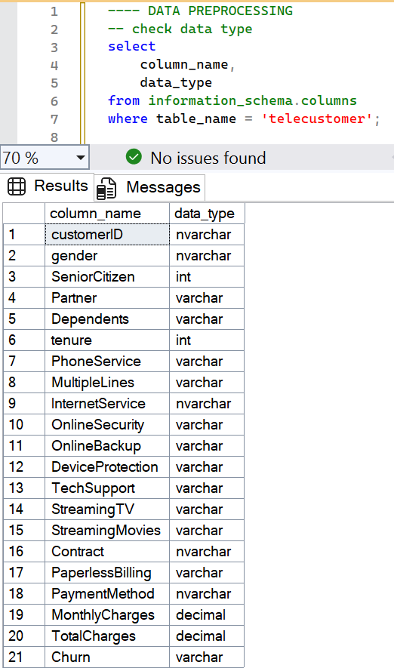
Figure 1

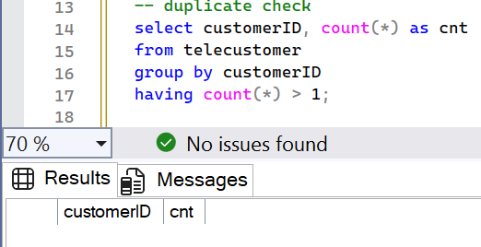
Figure 2
A duplicate check was performed and returned zero duplicates, confirming all 7043 rows represent distinct customers.

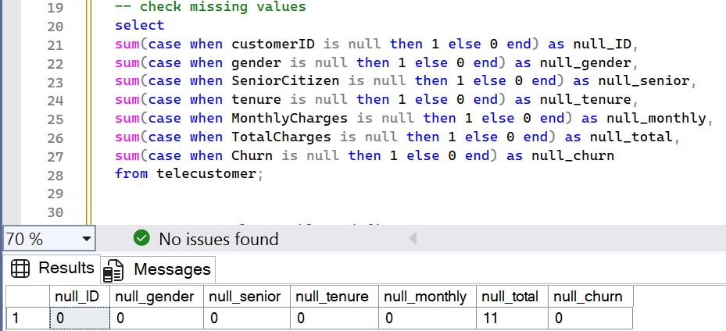
Figure 3
The missing values check returned 11 null values in the TotalCharges column and zero missing values elsewhere. These nulls originated from blank entries in the raw file which SQL Server could not convert to decimal during import, its automatically substituting of null. All 11 missing rows have tenure = 0, indicating that they are brand new customers who have not completed a billing cycle.

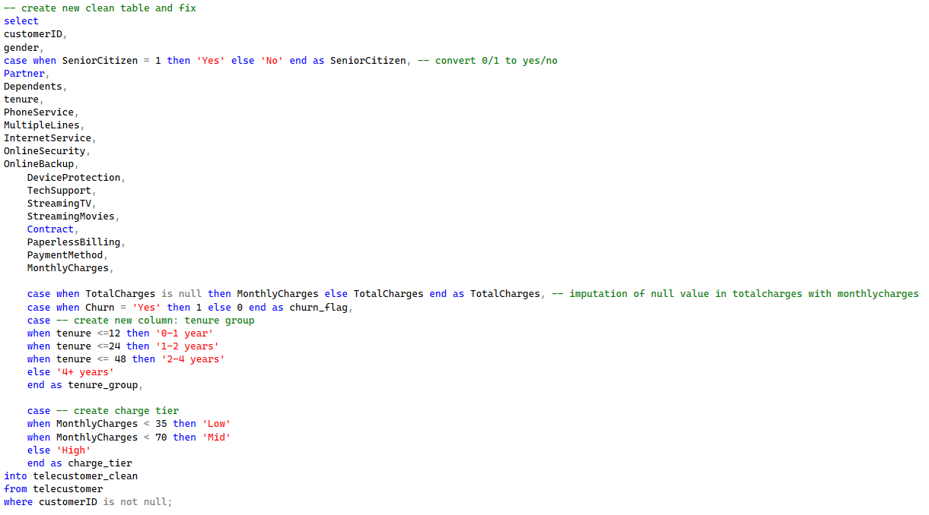
Figure 4
All cleaning steps were applied within a SELECT INTO statement that creates a new permanent table, 'telecustomer_clean,' which preserves the raw data entirely and makes every transformation explicit and repeatable.
To enhance the readability of queries and Power BI visualizations, we first convert SeniorCitizen from an integer to a Yes/No value. For the missing values in TotalCharges, we will impute the blank entries with the MonthlyCharges value instead of mean or median substitution. Since they are new customers and have not billed for their first month, their total charge to date should logically equal exactly one month of charges. Using mean or median would introduce values that have no relationship to these specific customers' actual billing situations. Next, for the Churn column, we choose to convert it into a binary integer, allowing aggregate functions to directly calculate the related information without repetitive "case when" logic in every query.
Lastly, to support segmentation analysis, two additional columns were added. Tenure values in months were bucked into four groups: 0-1 year, 1-2 years, 2-4 years, and 4+ years to enable lifecycle stage analysis rather than analyzing 72 months individually. In order to analyze price sensitivity as a discrete segment rather than a continuous variable, MonthlyCharges was divided into three tiers: "Low" (< $35), "Mid" ($35-70), and "High" (> $70).

EDA analysis

Overview Distribution
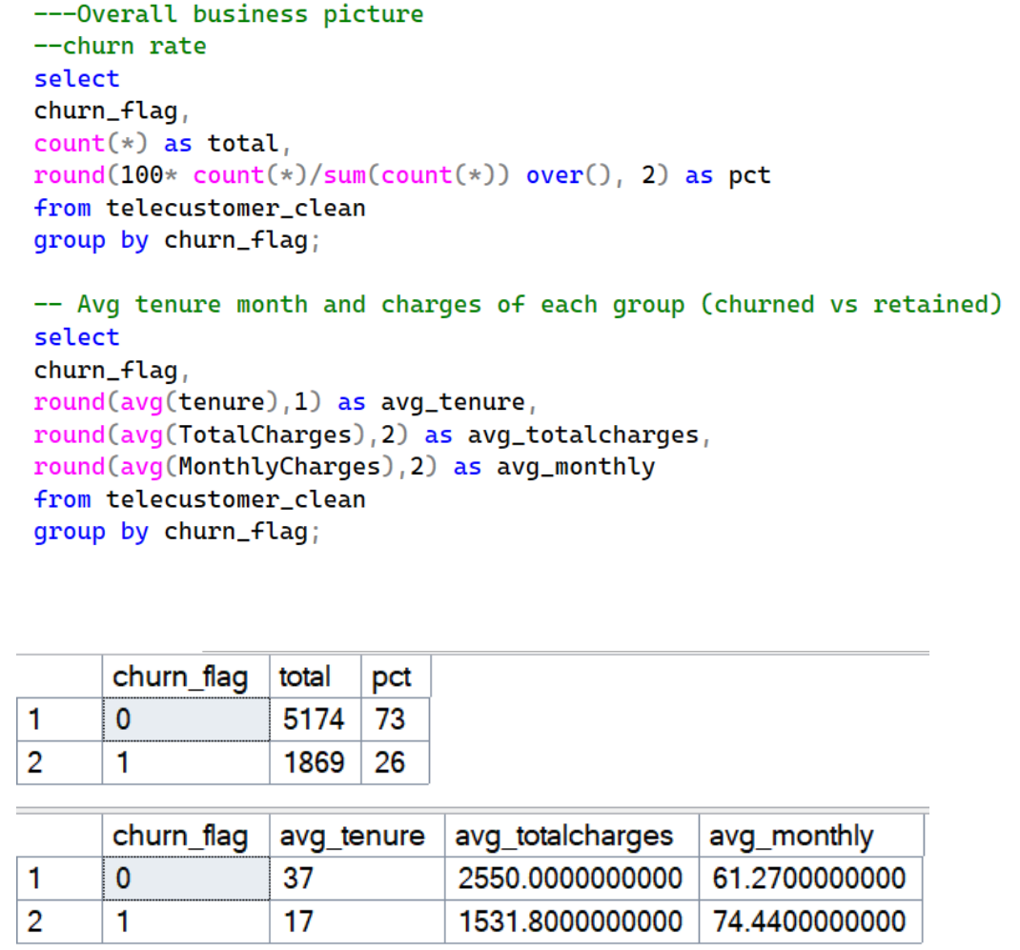
Figure 5

The overall churn rate of 26% (1869 customers), slightly higher than the telecom industry benchmark of 15-25% annually, indicates a significant retention problem.
Moreover, churned customers tend to have lower average tenure and higher average monthly charges than the retained ones, this suggests that newer high-paying customers are the most at risk.

Single Factor Analysis

Customer Profile
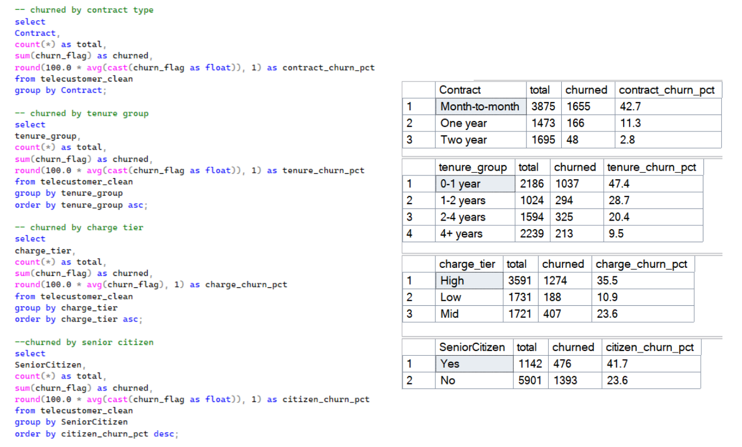
Figure 6
Customers' churn rate is 42.7% on a month-to-month basis, primarily due to the absence of early termination penalties and zero long-term commitment. Additionally, customers are inclined to switch to more advantageous promotions and offers (Lembhe et al. 2025).
The churn rate of 47.4% for customers in their first year shows that those who have not yet developed loyalty or dependency on the service are at the highest risk of churn, in contrast to those who have 4+ years of tenure, with only 9.5% of them leaving.
Customers in the high charge tier are churning at a rate of 35.5%, which suggests that their monthly spending may not be proportionate with the quality or value of the services, leading them to switch to lower-priced offers from competitors.
Senior citizens tend to leave more (41.7%) due to physical difficulties including deteriorating vision or dexterity, complicated digital interfaces, a lack of specialized support, and perplexing pricing models.

Payment & Services

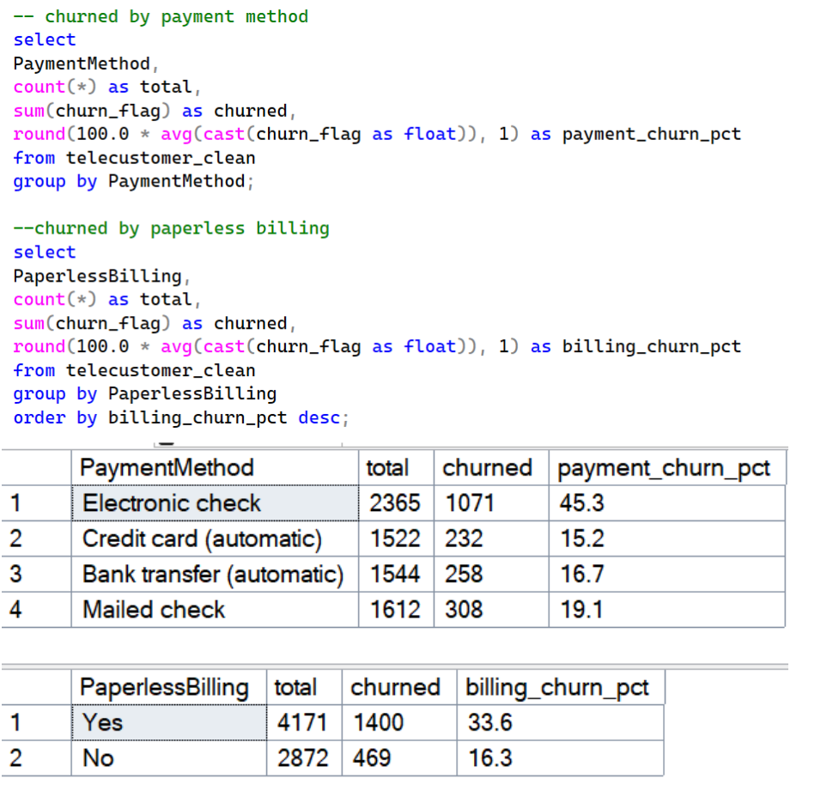
Figure 7
Customers using electronic check methods are likely to churn with the rate at 45.3%. This can be explained by the manual action or processing delays of each billing cycle that customers have to complete that create the inconvenience and frustration compared to the other automatic methods.

Similar trends show that consumers who use paperless billing also churn more frequently (33.6%). This is due to the fact that digital billing alerts are readily missed and buried within emails, which reduces the customer's feeling of engagement with the service (Accent 2023).
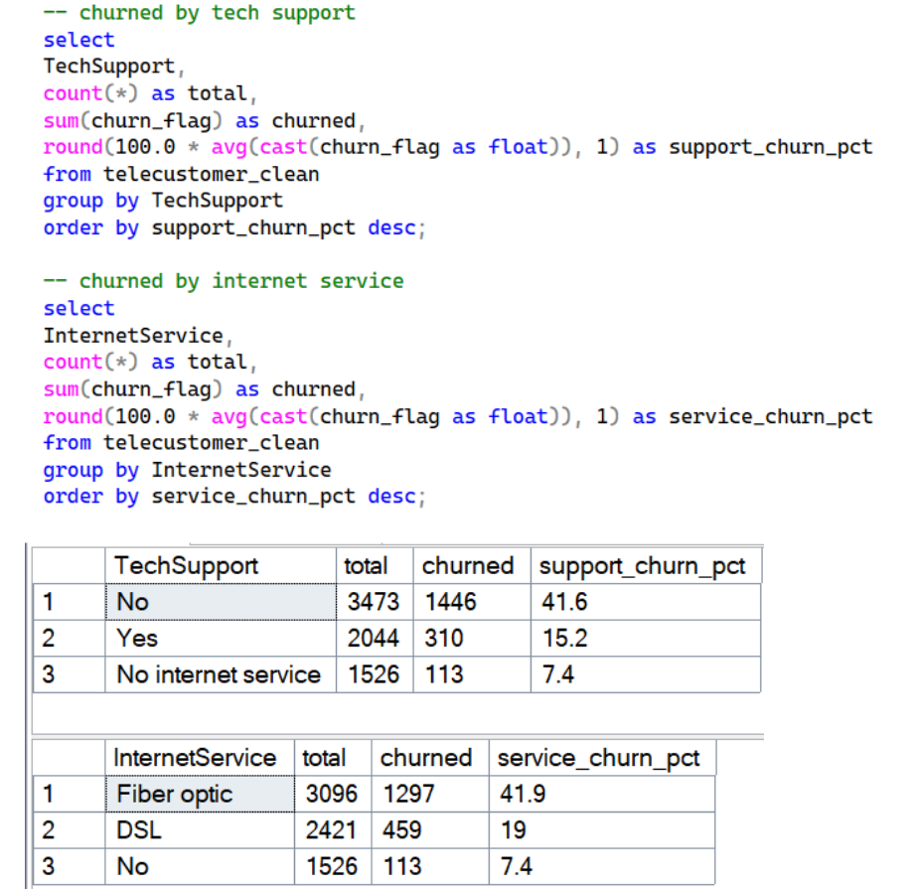

Figure 8
Up to 41.6% of customers leave without receiving any technical assistance. Unresolved technological problems have the potential to rapidly reduce consumer satisfaction and cause them to leave.

Customers that use fiber optic service leave at the highest rate (41.9%), which may be caused by a gap between their expectations and their actual service experience.

Relationship Analysis

Tenure Group x Charge Tier
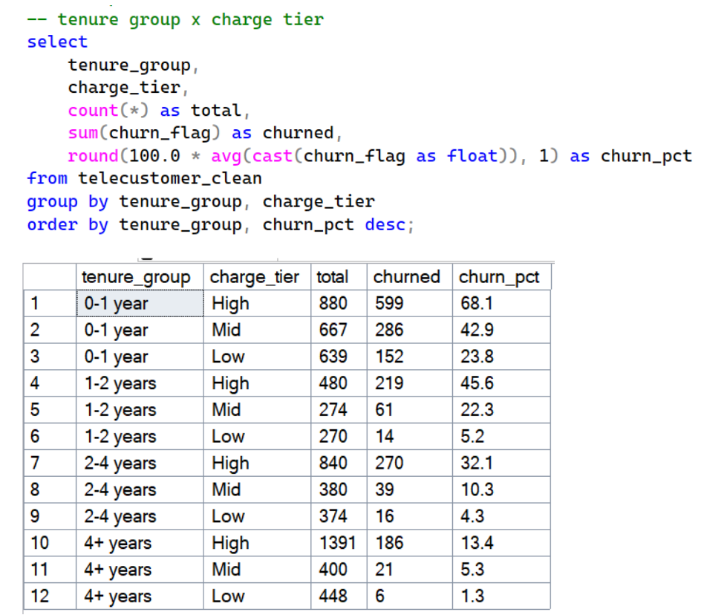
Figure 9
High charge tier customers show the steepest churn decline as tenure increase, confirming that price dissatisfaction is most acute before customers have accumulated sufficient experience of their spend. After the 2 year mark, the gap between 2 factors narrows considerably, indicating that loyalty gradually moderates price sensitivity regardless of spend level.

Contract x Tenure Group
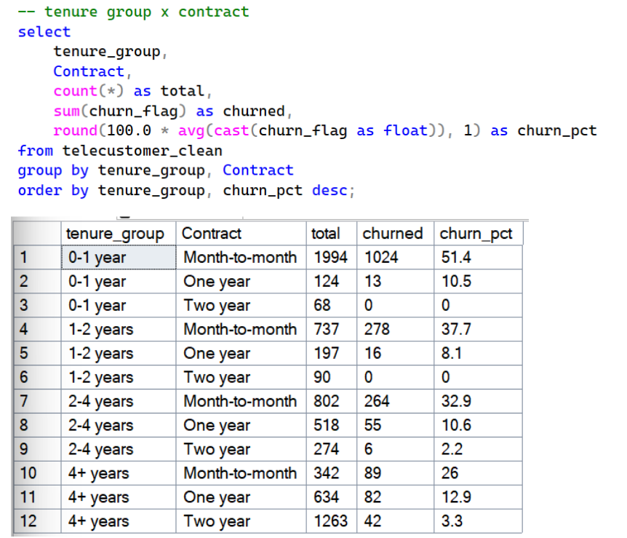
Figure 10
1st year month-to-month contract customers churn the most, yet even 1st year customers on longer contracts show elevated or even zero churn, confirming that tenure is a stronger loyalty driver than contractual obligation. The company should focus on the retention problem more than the contract design problem.

Internet Service x Tech Support
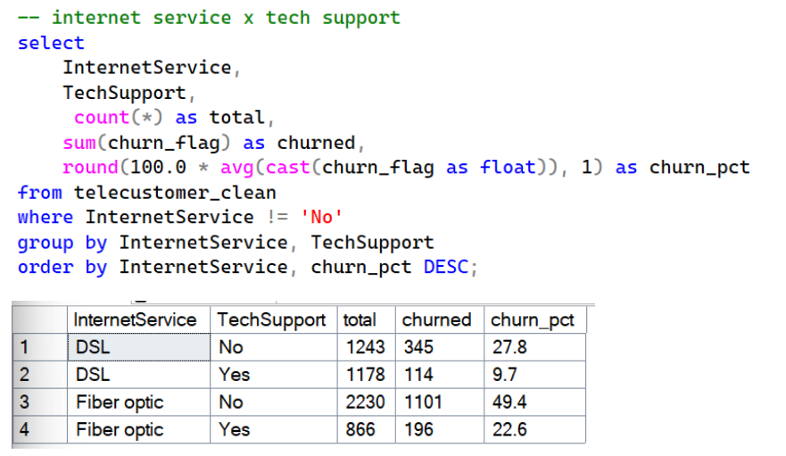
Figure 11
Fiber optic customers without tech support tend to leave the most and the gap with supported customers is wider in fiber optic than DSL , indicating that support is not a standard add-on but a critical retention lever specifically where service complexity and customer expectations are highest.

Internet Service x Charge Tier
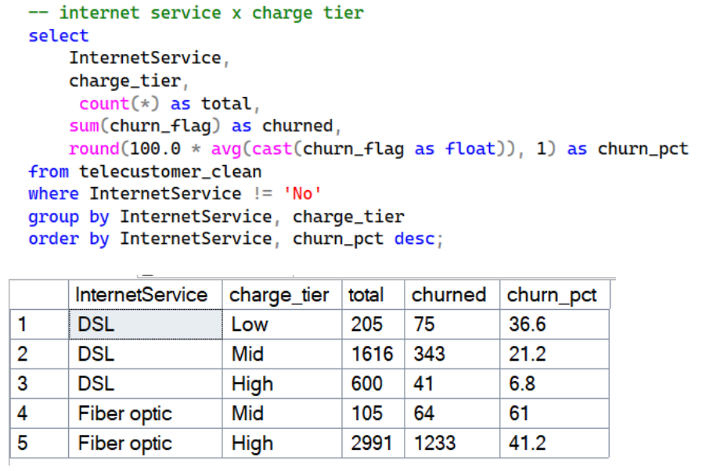
Figure 12
This relationship shows a contradictory view of the single-factor findings. This shows that within fiber optics, mid-tier customers churn more than high-tier, indicating that customers paying above average but not receiving the premium experience they expect are the most dissatisfied, while high-tier groups appear sufficiently invested to absorb service shortfalls. Moreover, DSL shows the opposing pattern, where low-tier customers churn the most, as minimal spending produces minimal perceived value and lower switching costs. These patterns show that the company may fail to align service quality with customer expectations across price points.

Contract x Payment Method
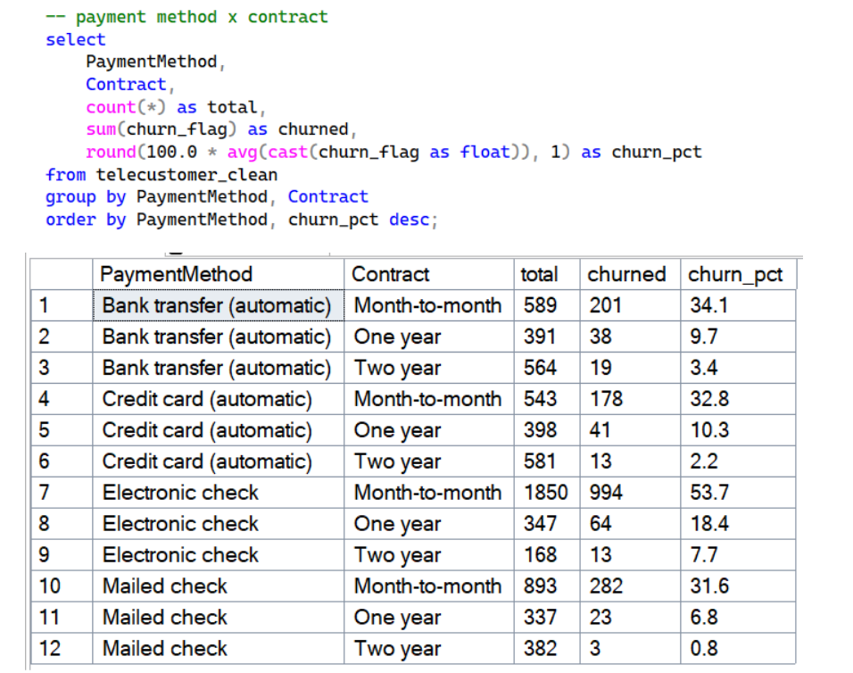
Figure 13
Month-to-month with electronic check customer leave the most (53.7%) indicates that automatic payment users on identical contracts churn considerably less, confirming that passive billing reduces churn independently of contractual commitment. The company's most disengaged customers are simultaneously free to leave and financially confronted every billing cycle.

Senior Citizen x Contract
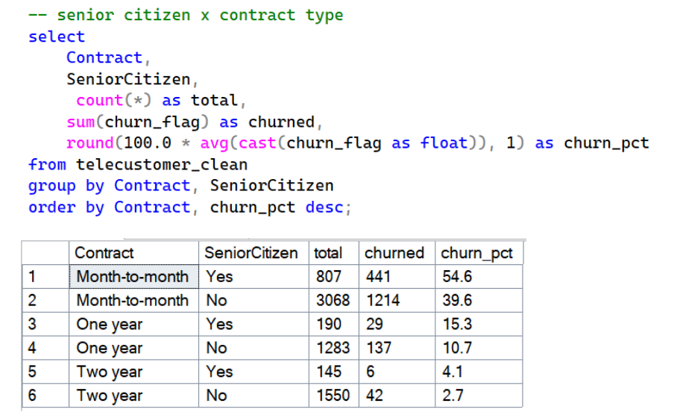
Figure 14
Seniors on month-to-month contracts churn at 54.6%, yet on two-year contracts their churn aligns closely with non-seniors. Age is not the driver, the absence of contractual structure is. Without it, the digital friction seniors experience converts directly into cancellation at a rate the company has left entirely unmanaged.

Revenue Impact

Monthly Revenue Loss
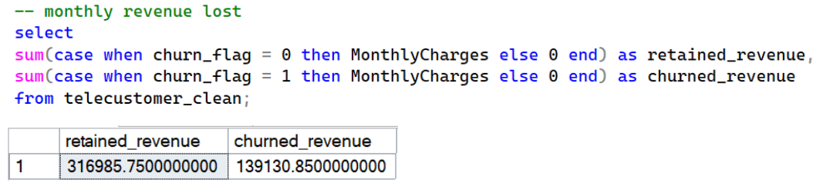
Figure 15
The company currently loses 139.130$ in monthly revenue from churned customers, translating to approximately 1.67$ million annually. Churned customers carry a higher average monthly charge than retained ones, indicating the company is disproportionately losing its higher-value customers rather than low-spend ones indicates the financial impact beyond what the 26.54% churn rate alone suggests.

Top 30 High-risk Customers by Risk Score
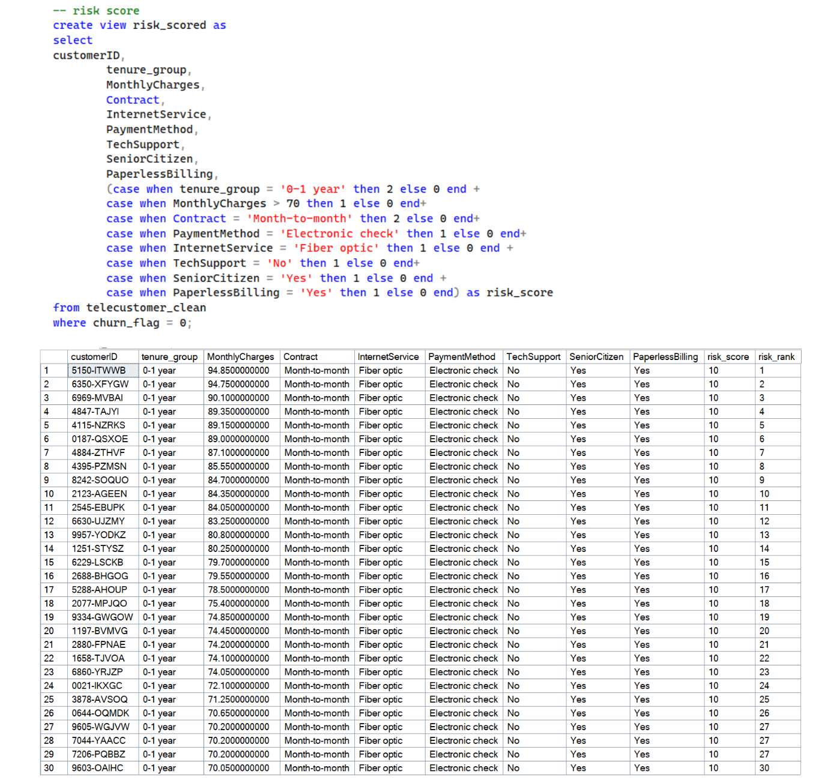
Figure 16
To define the top 30 highest customers at immediate risk, a scoring model was constructed across 8 churn predictors established in the analysis, where contract type and tenure group were assigned 2 points each as their stronger individual impact, while other factors were assigned 1 point each, producing a maximum score of 10.

Annual Revenue Loss if Current Churn Rate Continues

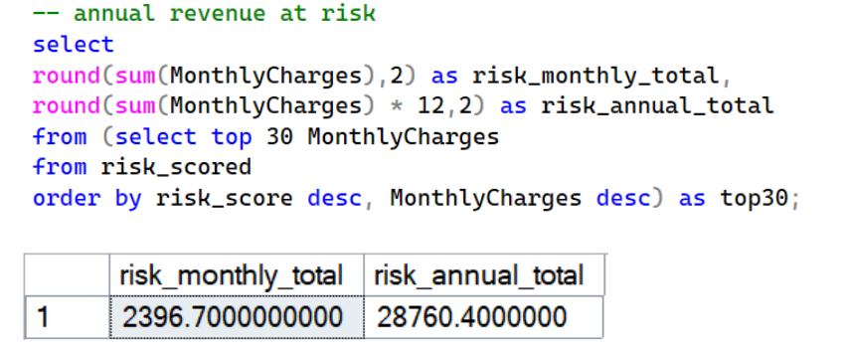
Figure 17
The top 30 highest-risk active customers represent an additional 2,396$ in monthly revenue at risk, 28,760$ annually if no intervention is made.

Visualization
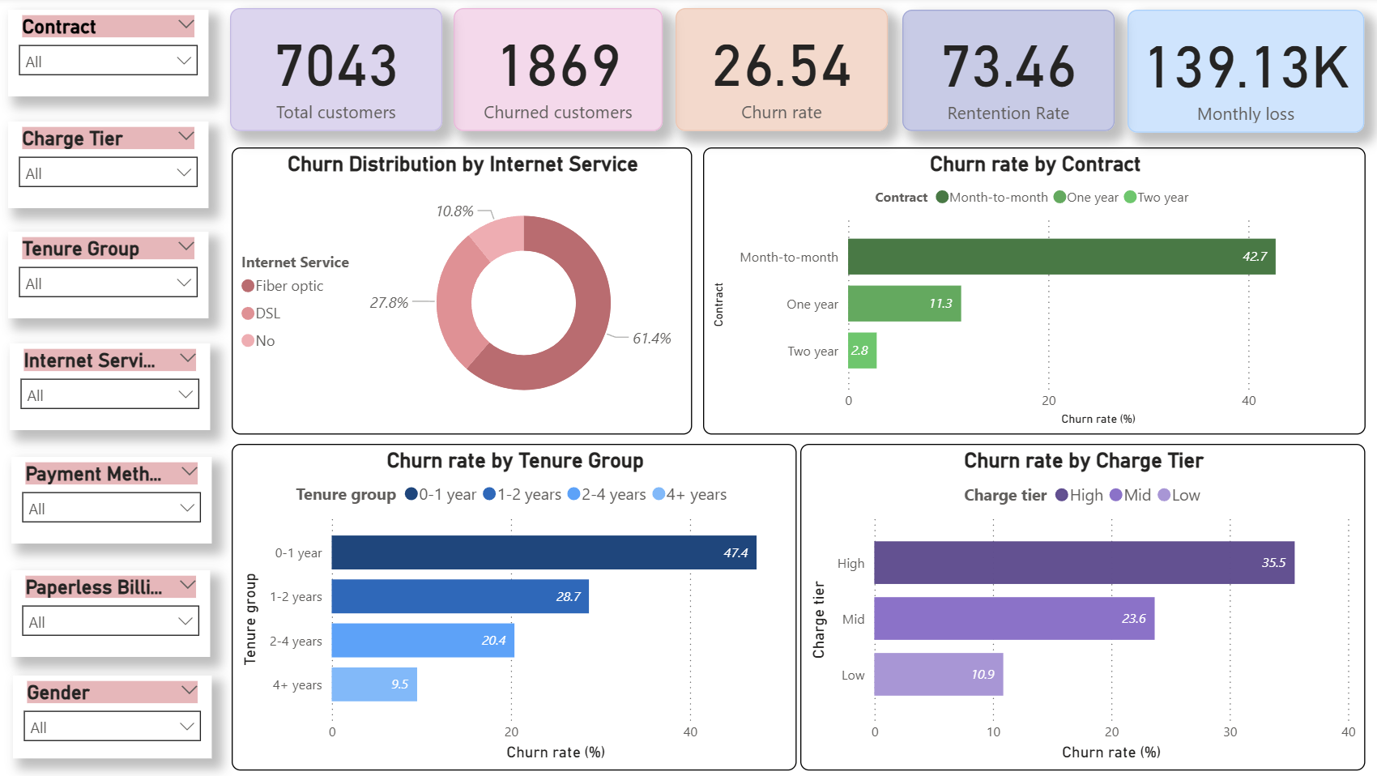
Figure 18
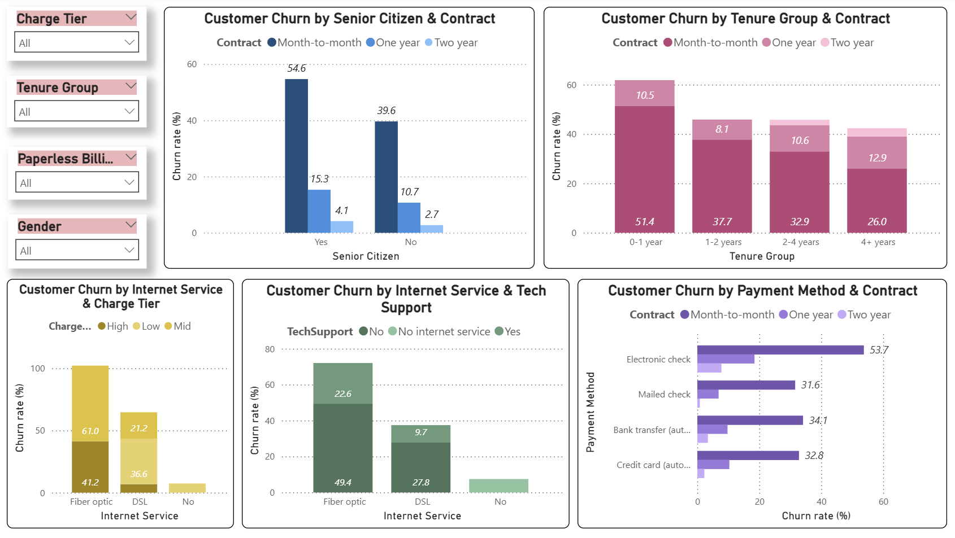
Figure 19

Predictive analysis
Following the explanatory analysis, logistic regression was applied to validate which factors statistically independently and significantly impact churn, controlling for all variables simultaneously. Logistic regression was chosen instead of linear regression because the outcome variable, churn_flag, is binary.

Variables Conversion
Before running the model, variables need to convert into formats the regression equation can process.
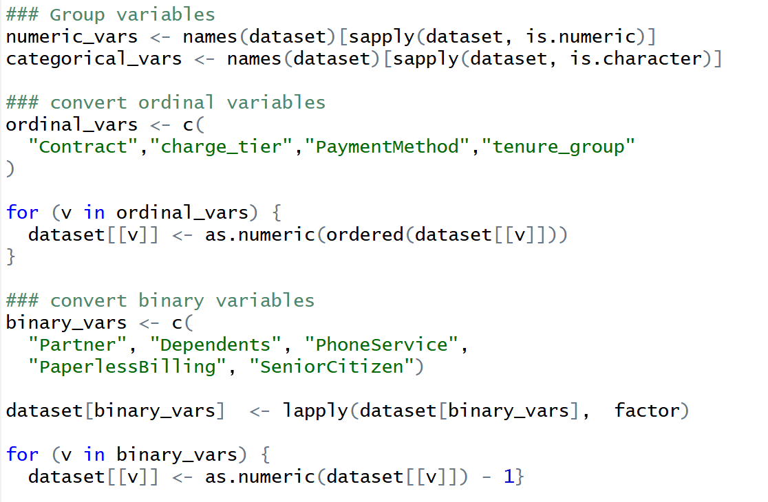
Figure 20
Firstly, columns following a natural progression will be grouped as ordinal variables and converted to ordered numeric values to preserve the directional relationship in the model rather than treating each band as an unrelated category. Next, binary columns with just 2 meaningful responses (Yes/No) were converted to 1 and 0 directly.
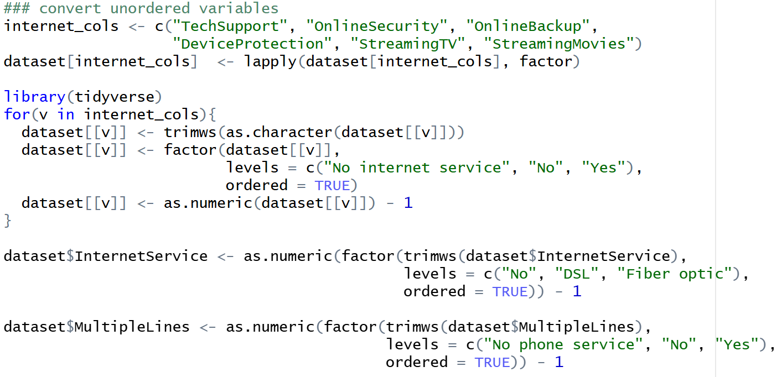
Figure 21
The unordered categorical variables, which include the ‘No service’ category with no natural ranking order, cannot be converted to numeric values directly because it would imply an ordinal relationship that does not exist. Instead, rearrange the levels first, then convert to numeric, starting from 0.

Model Interpretation
The full model includes all variables except MonthlyCharges, TotalCharges, and tenure because it was grouped to charge_tier and tenure_group.
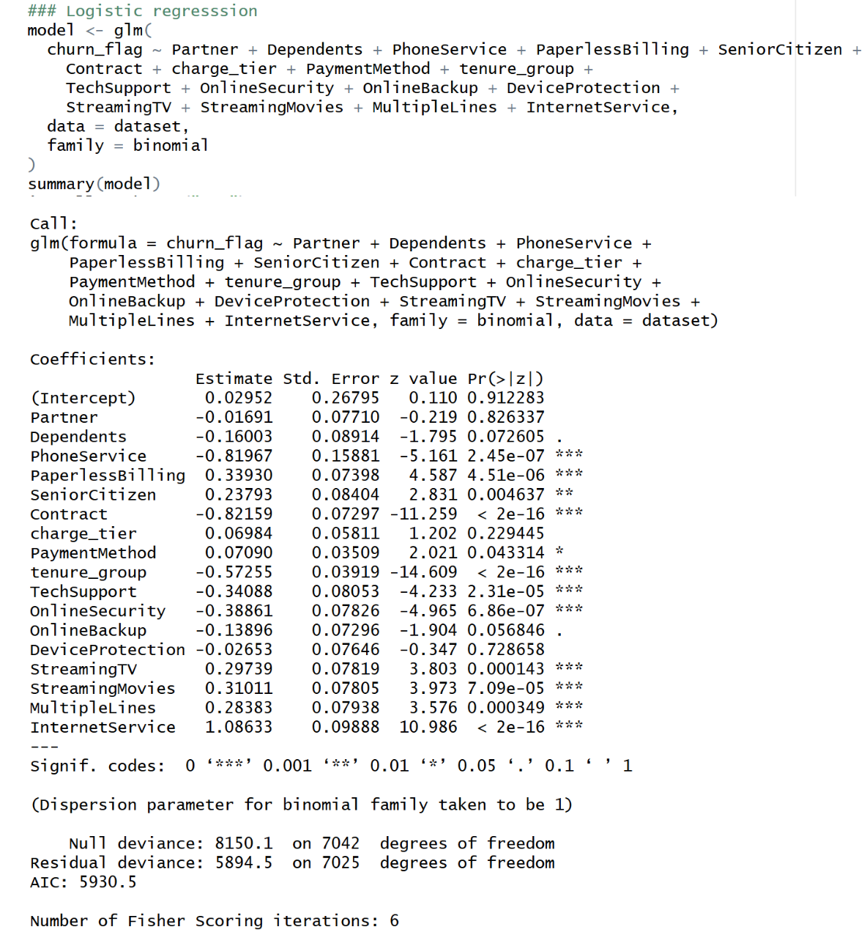
Figure 22
The result shows that Contract, tenure_group, InternetService, TechSupport, PaymentMethod, PaperlessBilling, and SeniorCitizen are significant predictors, confirming the pattern identified in the exploratory analysis. The direction of the coefficient also aligns well with EDA findings, further strengthening the credibility of both sets (longer contracts and tenure reduce churn, while fiber optics and electronic checks increase it).
However, there are some notable divergences in these results.In the EDA, charge_tier appears to show clear churn patterns, yet it is not significant in the regression. This discrepancy is likely due to confounding: charge_tier is inherently linked to both InternetService and Contract. For example, fiber optic customers tend to have higher charges, and month-to-month customers pay full price without loyalty discounts. As a result, the apparent effect of charge_tier in EDA is largely absorbed by InternetService and Contract when included together. Supporting this, EDA shows that churn patterns within charge tiers vary substantially across service types, indicating that service type mediates the price–churn relationship rather than price acting independently.
Additionally, StreamingTV, StreamingMovies, and MultipleLines were statistically significant in regression but were excluded from EDA because they showed no clear visual churn differentiation. Their effects are subtle relative to dominant variables, making them hard to detect in univariate plots. Regression, by controlling for all other factors simultaneously, isolates each variable’s independent contribution and uncovers smaller but genuine effects. The positive coefficients suggest that entertainment add-ons do not enhance loyalty; customers who subscribe to more services may be more digitally engaged and comfortable switching providers.
Finally, customers with PhoneService are significantly less likely to churn, likely reflecting a bundling effect: having multiple services from the same provider increases switching costs and inertia beyond the effect of any single service.

Confusion Matrix
The confusion matrix was used to evaluate how well the model translates statistical relationships into actual predictions by comparing predicted outcomes against real outcomes across all customers.

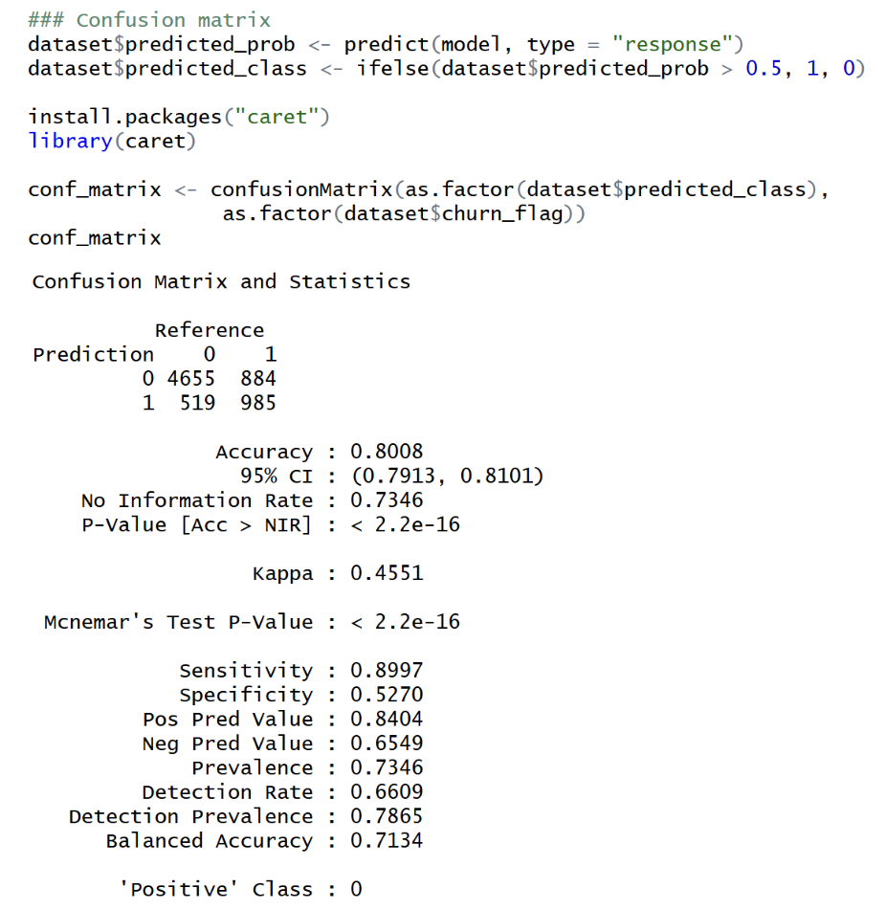
Figure 23
- Accuracy: The model correctly classified 80% of all customers, meaningfully exceeding the no-information rate of 73.46%, confirmed by p < 2.2e-16, demonstrating the model extracts a genuine predictive signal.
- Sensitivity: The model correctly identifies 89.97% of retained customers, indicating strong performance at recognizing loyal behavioral patterns.
- Specificity: The model correctly identifies only 53% of actual churners, meaning nearly half of customers who will churn are misclassified as retained. In a business context, this imbalance is costly; the 884 missed churners represent customers who received no retention intervention despite being at genuine risk.
- Kappa: 0.4551 indicates moderate agreement beyond chance, confirming the model performs meaningfully above random prediction despite the class imbalance.

Top 30 High-risk Customer by Probability
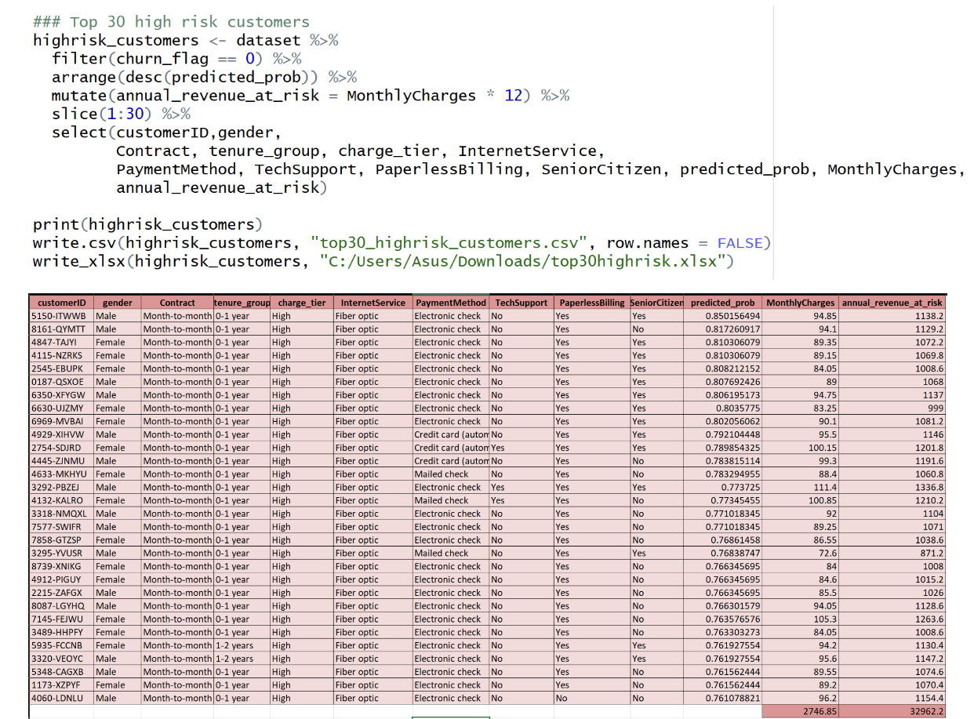
Figure 24
The 30 active customers with the highest predicted churn probability represent the most statistically urgent retention targets. Given the model's 52.7% specificity, however, this table should not be treated as a definitive prediction; some genuinely at-risk customers may not appear, while some listed may ultimately stay. This limitation can be addressed by cross-referencing with the rule-based risk score table from EDA analysis. Customers flagged by both approaches represent the highest confidence retention priorities, combining statistical evidence with business logic validation. These customers should be treated as the most defensible targets for immediate intervention.

Limitations
Several limitations should be acknowledged. The charge tier was engineered using fixed boundaries, introducing segmentation subjectivity, and its confounding relationship with internet service and contract type was assessed through business reasoning rather than formal statistical testing. Additionally, the model was evaluated on training data without a holdout validation set, meaning predictive performance metrics may be slightly optimistic. These limitations do not invalidate the significant findings but should be considered when applying results to operational decisions.

Conclusion and Recommendations
The analysis shows that customers with short tenure, month-to-month contracts, fiber optic service, senior citizen status, no technical support, and electronic check payments with paperless billing consistently represent the highest churn risk, across both exploratory and regression analyses. Optional add-ons, such as StreamingTV and StreamingMovies, do not improve retention, while PhoneService reduces churn, indicating bundling of essential services strengthens loyalty. The company’s weaknesses lie in pricing and contract structures that offer limited early-stage incentives, a premium service that falls short of expectations, and a large customer segment with no retention mechanism. Without improvements to the retention strategy, Telco faces significant financial consequences, including ongoing revenue loss and additional revenue at risk from active high-risk segments.

To reduce churn and increase revenue, Telco should:
- Enhance contract incentives for short-term customers
Encourage month-to-month subscribers, particularly those in their first year, to move to longer-term contracts by offering discounts, loyalty points, or bundled upgrades. Implement tiered retention benefits so that the longer a customer stays, the more value they receive, reducing early churn and increasing the perceived cost of leaving (Bariha 2020).
- Fiber optic support and service quality
The company should ensure default inclusion of tech support or offer discounted support packages for fiber optic customers. Communications should emphasize the full value proposition: reliability, dedicated support, and service guarantees, to align customer expectations with the service provided and reinforce the premium nature of the offering (Schwarz 2025).

- Optimise service bundling and payment migration
Bundled packages combining internet, phone, and other core services should be promoted to enhance perceived value and increase switching costs. Concurrently, customers should be encouraged to migrate from electronic check to automatic payment methods, thereby reducing billing friction (Ribeiro et al. 2023).
- Early tenure engagement and senior citizen strategy
A structured onboarding program should be established for customers within the first 12 months, the period of highest churn, focusing on proactive communication of service benefits. For senior citizens, tailored initiatives such as simplified pricing plans, dedicated support channels, and guided contract upgrade options can mitigate elevated churn risks, demonstrating that these behaviors are addressable rather than inevitable (Bariha 2020).

- Targeted intervention and continuous monitoring
The company should use predicted churn probabilities to deliver personalised campaigns, proactive support, premium service trials or exclusive offers, prioritising customers combining high churn likelihood with significant revenue contribution. Re-run predictive models periodically and complement with qualitative customer feedback to ensure retention strategies remain responsive to evolving churn drivers and market conditions (Schwarz 2025).

If the above suggestions are applied to reduce churn rate from 26.5% to 20%, the company can retain approximately 461 additional customers, equivalent to 411,800$ in revenue/year preserved (based on the average spending of 74.44$/month of the customer group at risk of churn).

References

Accent (2023) Is Paperless Billing Actually the Best Thing for Your Customers?, Accent Opaque website , accessed 2 June 2026. https://accenton.accentopaque.com/is-paperless-billing-actually-the-best-thing-for-your-customers
Anisha R, Uma B and Gowda M (2025) ‘Customer Churn Prediction in Telecom Industry’, INTERNATIONAL JOURNAL OF INNOVATIVE RESEARCH IN TECHNOLOGY, 12(6).
Bariha PP (2021) ‘Customer Loyalty Program and Retention Relationship’, Psychology and Education Journal, 58(1):5069–5074, doi:10.17762/pae.v58i1.2012.
Lembhe A, Lagad Y, Kamthe R and Swami A (2026) ‘View of Survival Analysis of Customer Lifetime and Churn Prediction in the Telecom Industry, INTERNATIONAL JOURNAL OF LATEST TECHNOLOGY IN ENGINEERING, MANAGEMENT & APPLIED SCIENCE , 14(13):201, doi:10.51583/IJLTEMAS.
Ribeiro H, Barbosa B, Moreira AC and Rodrigues R (2023) ‘A closer look at customer experience with bundle telecommunication services and its impacts on satisfaction and switching intention’, Journal of Marketing Analytics, 12:668–686, doi:10.1057/s41270-023-00222-w.
Schwarz L (2025) 8 Customer Retention Strategies for Telecom Companies, Oracle NetSuite website, accessed 8 June 2026. https://www.netsuite.com/portal/resource/articles/erp/customer-retention-telecom.shtml

